CHRISTMAS COOKIES

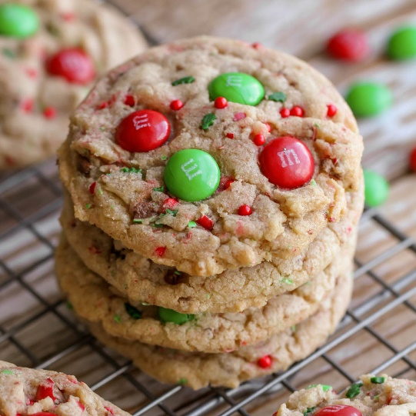
INGREDIENTS
- 1 cup brown sugar
- 1 cup sugar
- 1/2 cup butter
- 1/2 cup oil
- 2 eggs
- 1 tsp baking soda
- 1 tsp salt
- 1 tsp baking powder
- 1 tsp vanilla
- 3 cups flour
- 1/2 cup sprinkles (or mini chocolate chips)
- 1 cup M&Ms

INSTRUCTIONS
- Preheat oven to 350. Cream butter, oil and sugars. Add eggs and beat until fluffy.
- Add baking soda, salt, powder, vanilla and flour. Mix well.
- Fold in sprinkles. Use cookie scoop to put on greased cookie tray. Top with 4-5 M&Ms.
- Bake at 350 for 7-8 minutes.

